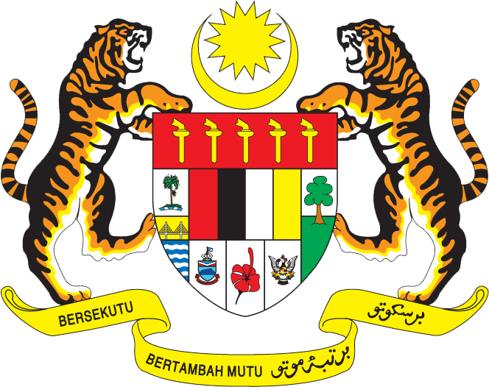

Statement by H.E. Ambassador Dato’ Amran Mohamed Zin
Permanent Representative of Malaysia to the United Nations Office and Other International Organizations in Geneva
32nd Session of the UPR Working Group: Review of Viet Nam
22 January 2019

Mr. President,

The Malaysian delegation warmly welcomes His Excellency Deputy Minister of Foreign Affairs Le Hoai Trung and the Vietnamese delegation. We congratulate them for their comprehensive UPR report and presentation.

- Malaysia commends Viet Nam for the remarkable achievements in its national developments, including in the field of human rights. The improvements to legislations, institutions and policies, as well as continuous efforts to further promote social welfare and increase living standard undertaken by Viet Nam have resulted in greater and meaningful progress for the country and well-being of its people.

- In the context of the Viet Nam’s UPR, Malaysia wishes to make two recommendations:

  - One: Continue to conduct studies with a view to amend existing or introduce new legal instruments to eliminate all forms of discrimination against people living with HIV; and

  - Two: Promote access to information in accordance with Viet Nam’s National Law.

- As a fellow ASEAN member, Malaysia is also appreciative of Viet Nam’s important contributions to the ASEAN Community building and realization of ASEAN common human rights agenda.

- We wish Viet Nam a successful review.

Thank you.

GENEVA
22 January 2019

