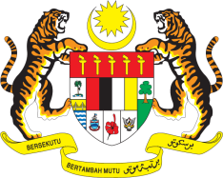

STATEMENT BY MALAYSIA
Review of Chile
32nd Session of the UPR Working Group
22 January 2019

Thank you, Mr. President.

Malaysia warmly welcomes the distinguished delegation of Chile and thanks them for the presentation of their national report.

- Malaysia commends the Government of Chile for its achievements to further improve human rights conditions in the country since its second UPR. We note that Chile continues to develop a wide range of social infrastructures, public healthcare and education systems for its people.

- Malaysia also notes that numerous laws have been adopted to safeguard the rights of persons with disabilities. Taking into account the observations by the Committee on the Rights of Persons with Disabilities, Malaysia recommends that Chile establishes a national mechanism to further increase participation, accountability, inclusion as well as empowerment of persons with disabilities.

- Moving on, Chile’s Council of Older Persons and the ‘Older Life, Better Life’ programme are commendable. Malaysia is of the view that there is a need to further identify appropriate strategies that could adequately address the situation of older persons. In this regard, Malaysia recommends Chile to streamline efforts and include the participation of relevant stakeholders including civil society to reduce the marginalisation of older persons and increase their inclusion into society.

GENEVA
22 January 2019

