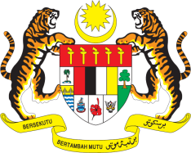

STATEMENT BY MALAYSIA
Review of Afghanistan
32nd Session of the UPR Working Group
21 January 2019

Thank you, Mr. President.

Malaysia welcomes the delegation of Afghanistan to the 32nd Session of the UPR Working Group and expresses appreciation for their detailed presentation of national report.

- Afghanistan’s commitment to the promotion and protection of human rights in the country, as attested by various national policy developments, is commendable. My delegation notes the efforts to foster culture of human rights among various segments of the society through trainings and campaigns. The Government has embraced a whole of society approach by including non-governmental organizations in its endeavour.

- Malaysia welcomes measures to promote empowerment of women. Various strategies and establishments including Gender Strategy, National Action Plan for Women, Women Chamber of Commerce are indeed, steps in the right direction to further advance women’s political, social, economic and health status.

- With all of these developments in mind and in the spirit of constructive engagement, Malaysia would like to recommend to the Government of Afghanistan to continue its efforts in the promotion and protection of human rights in the country by strengthening its national policies and programmes to further improve the well-being of its people. We also recommend that Afghanistan develops a robust mechanism to address poverty in the country.

Thank you.

GENEVA
21 January 2019

