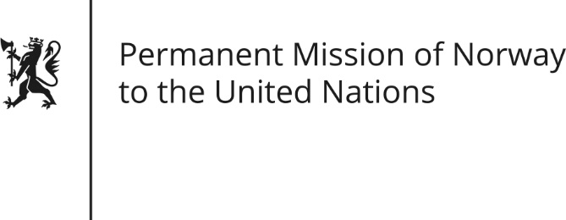

STATEMENT by Minister Counsellor Herborg F. Alvsaaker

32nd Session of the Universal Periodic Review

Cambodia

30 January 2019

Check against delivery

President,
Norway welcomes Cambodia’s participation in the UPR-mechanism [and for the presentation of the national report].
We remain concerned about democratic developments, including the recent elections [and the treatment of human rights activists].
Norway recommends that Cambodia:
- Restores democratic and political space, ensuring participation for political parties, civil society and independent media.

- Immediately releases from custody any individual detained for their peaceful exercise of freedom of expression and assembly, and drop all criminal charges against these [individuals].

- Completes the process of judicial reform [safeguarding independence and impartiality of the court system, court personnel and judges] in accordance with international standards.

- Intensifies efforts to improve human rights for women and combat human trafficking, [domestic violence and exploitation of women and children].

Thank you.

