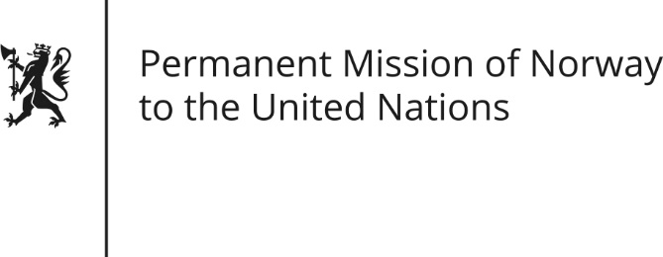

STATEMENT by Permanent Representative Hans Brattskar

32nd Session of the Universal Periodic Review

Eritrea

28 January 2019

Check against delivery

President,
Norway welcomes Eritrea’s participation in the UPR process. The rapprochement with Ethiopia in 2018 is of great importance and gives hope for positive developments in the area of human rights.
Norway recognizes some positive steps taken by Eritrea, especially concerning women’s rights. However, Norway remains gravely concerned about the overall human right situation
We remain committed to support Eritrea’s realization of its human rights obligations.
Norway recommends that Eritrea:
- Improve the administration of the justice system by carrying out judicial and penitentiary reforms in order to ensure compliance with international human rights law.
- End practice of national service beyond the statutory 18 months and begin a phased demobilization.
- Cooperate with the international community, including OHCHR and UN special procedures mandate holders, in efforts to verify, promote and protect human rights.
- Release or bring before a court all persons detained without a charge.

- Develop a National Action Plan for the implementation of the United Nations Guiding Principles on Business and Human Rights.
Thank you.

