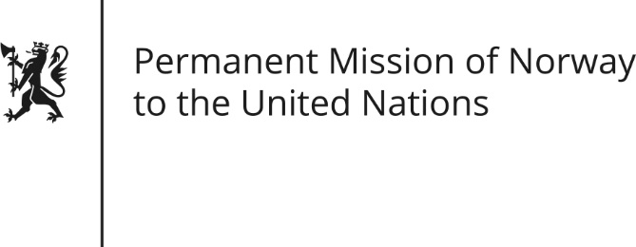

STATEMENT by First Secretary Sean Lobo

32nd Session of the Universal Periodic Review

Slovakia

28 January 2019

Check against delivery

President,
Norway thanks the delegation of Slovakia for presenting its national report. We commend Slovakia for its efforts towards Roma inclusion.
Norway recommends that Slovak authorities increase their efforts even further to protect the Roma population against discrimination, in particular segregation of Roma children in education.
Further, we recommend that Slovakia integrates the UN SDG Number 5 on gender equality in the National Strategy and National Investment Plan for 2018-2030, and ratifies The Council of Europe Convention on preventing and combating violence against women and domestic violence.
Norway recognizes Slovakia’s acceptance towards same-sex marriages for residency purposes. We recommend that Slovakia again initiate a plan to adopt a National Action Plan on LGBTI equality.
Finally, Norway recommends a further strengthening of the National Human Rights Institution, the Slovak National Centre for Human Rights, to assure that it fully comply with the Paris principles.
Thank you.

