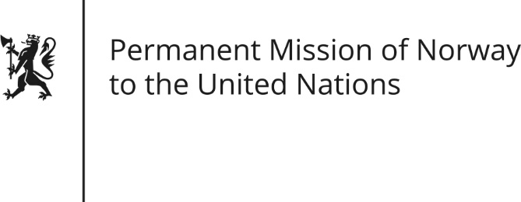

STATEMENT by Permanent Representative Hans Brattskar

32nd Session of the Universal Periodic Review

Yemen

23 January 2019

Check against delivery

President,
Norway welcomes Yemen’s participation in the UPR and the constructive engagement the government has demonstrated during the recent political talks in Sweden.
Notwithstanding, the situation for the Yemeni people remains of great concern.
Norway recommends Yemen to:
1) Continue its engagement in the political process and ensure full and unhindered humanitarian access.
2) Work actively with the international community in investigating violations of international human rights and humanitarian law, including in cooperation with the Group of Eminent Experts.
3) Ensure that no children are recruited as soldiers
4) Ensure women's representation in [all levels of] the political process, [and take effective measures to protect women against gender-based and sexual violence,]
5) Investigate promptly the allegations of arbitrary detention, torture and ill-treatment, including against the Baha’i community and other victims of religious persecution, and ensure accountability in line with international standards.
Thank you

