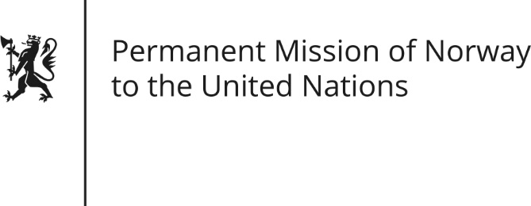

STATEMENT by Minister Counsellor Herborg F. Alvsaaker

32nd Session of the Universal Periodic Review

Vietnam

22 January 2019

Check against delivery

President,
Norway welcomes Vietnam’s participation in the UPR and commends progress in certain areas since the last UPR. Despite these improvements, we remain concerned about the situation for human rights defenders and religious minorities.
Norway recommends that Vietnam:
- Revises provisions art.117 and 331 of the Penal Code 2015 and other relevant laws that restrict the ability to exercise fundamental freedoms and allow free operation of national and international media [in accordance with its international human rights obligations under the ICCPR].
- Continues to reduce the scope of crimes subject to the death penalty only for “most serious crimes”, [as stated in Article 6 of the ICCPR], and consider introducing a moratorium.
- Ratifies ILO’s core conventions no. 87 [“Freedom of Association and Protection of the Right to Organise Convention”], no. 98 [“Right to Organise and Collective Bargaining Convention”] and no. 105 [Abolition of forced labour].
- Explicitly provides “sexual orientation” and “gender identity” as a forbidden ground of discrimination in the revised labour code and other relevant laws.
Thank you.

