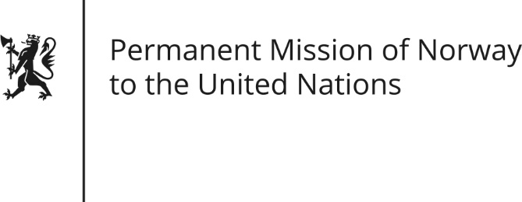

STATEMENT by First Secretary Sean Lobo

32nd Session of the Universal Periodic Review

Chile

22 January 2019

Check against delivery

President,
Norway welcomes Chile’s participation in the UPR and commends Chile’s efforts to protect and promote human rights.
Norway recommends that Chile:
- Gives urgent attention to adopt a bill on comprehensive protection of children that ensures compliance with the Convention on the Rights of the Child.
- Revises abortion legislation in accordance with CEDAW’s recommendations, especially with regard to rules on conscientious objection [to ensure the protection of access to legal abortion].
- Strengthens the implementation of ILO Convention 169, especially with regard to an independent evaluation of national mechanisms for consultation [and participation of indigenous peoples].
- Ensures that the application of the Counter-Terrorism Law does not violate the human rights of indigenous people.
Thank you.

