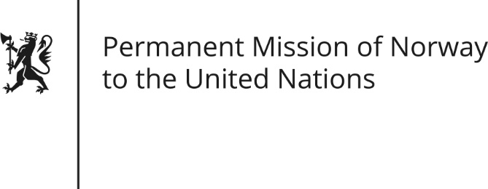

STATEMENT by Permanent Representative Hans Brattskar

32nd Session of the Universal Periodic Review

Afghanistan

21 January 2019

Check against delivery
President,
Norway notes the positive steps taken and appreciates considerable degree of conformity between Afghanistan’s legislative framework and international Human Rights obligations, (as was recommended by Norway in the 2014 UPR). Norway also appreciates efforts to improve women’s situation, but remains worried about quality of implementation. Norway commends the follow-up of Afghan Independent Human Rights Commission’s recommendations.
Norway recommends to:
- Promptly investigate and prosecute cases of violence against women in line with international human rights standards, including so-called honor killings.
- Ensure protection of schools, education and pupils in accordance with Afghanistan’s commitment as a signatory of the Safe School Declaration [in Oslo, May 2015 and in line with SDG goals].
- Take further concrete measures to improve conditions for journalists and human rights defenders
- Promptly and thoroughly investigate all allegations of torture of detainees, enforced disappearances and summary executions, and prosecute those responsible in line with international human rights standards.
Thank you.

