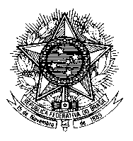

Permanent Mission of Brazil to the United Nations Office
and other International Organizations in Geneva

Universal Periodic Review

32nd Session

New Zealand

1’30’’

Mr. President,

Brazil welcomes the delegation of New Zealand to the UPR and, in a spirit of cooperation and constructive dialogue, would like to make the following recommendations:

1) While implementing the Family and Whanau Violence Legislation Bill, take further steps to address the needs and rights of indigenous women and girls; and

2) Enhance mental health policies with a view to guaranteeing that persons with mental health conditions and psychosocial disabilities have access to appropriate mental health services, including community-based care, which respect their dignity and human rights.

We take this opportunity to congratulate New Zealand for the progress achieved in incorporating previous UPR recommendations in its National Plan of Action for the Protection and Promotion of Human Rights.

We also commend the country for taking steps to protect the Bill of Rights Act by enabling senior courts to assess the consistency of ordinary laws with fundamental rights, and for adopting the Disability Strategy 2016-2026.

We wish New Zealand a very successful review.

I thank you.

(167 words)

