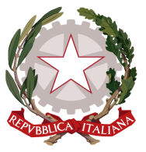
Permanent Mission of Italy to the
International Organizations in Geneva
Check against delivery
UPR 32 – Cambodia
30 January 2019
Delivered by H.E. Ambassador Gian Lorenzo Cornado, Permanent Representative of Italy to the United Nations in Geneva

Thank you, Mr. Vice President.

Italy welcomes the distinguished delegation of the Kingdom of Cambodia and thanks for the national report and today presentation.

Italy seizes this occasion to present the following recommendation:

- Strengthen efforts to protect the rights of the most vulnerable groups, such as women, children and persons with disabilities, also in order to prevent and combat child labor and sexual exploitation, as well as other forms of violence, including domestic violence

- Protect the rights of human rights defenders and bring laws, regulations and policies on freedom of expression, association and assembly into accordance with international obligations.

- Step up efforts in land matters, including through the effective and transparent implementation of measures to tackle land evictions and provide with fair compensation the victims of land grabbing, particularly indigenous people

- Continue to implement measures to strengthen the independence of both the judiciary and the media.

- Engage constructively with all UN special procedures

We wish Cambodia a successful review.
I thank you.

