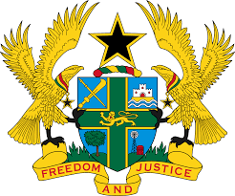
REPORT OF THE WORKING GROUP ON THE UNIVERSAL
PERIODIC REVIEW OF MONACO

STATEMENT BY GHANA DELIVERED BY MR ALEXANDER GRANT NTRAKWA,
DEPUTY PERMANENT REPRESENTATIVE, MONDAY 12TH NOVEMBER, 2018

Thank you, Mr. President.

Ghana welcomes the delegation of Monaco to the UPR process.

My delegation commends Monaco for adopting numerous domestic legislations and ratifying international human rights instruments to advance the promotion and protection of human rights in the country.

We note with satisfaction Monaco’s commitment to implementing recommendations it accepted during the second UPR Cycle, in particular the establishment in 2013 of the Office of the High Commissioner for the Protection of Human Rights and Freedoms and for Mediation, the Association for the Support of Victims of Crime in 2014 to provide support to victims of various acts of violence and other criminal offences, and ratification of the Convention on the Rights of Persons with Disabilities in 2017.

To further strengthen human rights in Monaco, Ghana makes the following three recommendations:

- Consider acceding to the Rome Statute of the International Criminal Court;

- Consider assigning to the High Commissioner for the Protection of Human Rights and Freedoms and for Mediation the function of providing victims of discrimination with legal aid, including during court proceedings;

- Ratify the Optional Protocol to the Convention against Torture.

Ghana wishes Monaco a successful UPR outcome.

I thank you.

