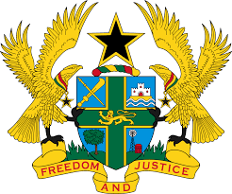
31ST SESSION OF THE UPR WORKING GROUP
5TH – 16TH NOVEMBER, 2018

REPORT OF THE WORKING GROUP ON THE UNIVERSAL
PERIODIC REVIEW OF SAUDI ARABIA

STATEMENT BY GHANA DELIVERED BY MR. JOSEPH OWUSU-ANSAH,
COUNSELLOR, ON MONDAY 5TH NOVEMBER, 2018

Thank you, Mr. President.

Ghana welcomes the delegation of the Kingdom of Saudi Arabia to the 3rd UPR Cycle.

My delegation lauds the adoption by Saudi Arabia of several domestic legislations since the 2nd Cycle of the UPR to strengthen the promotion and protection of human rights. We note in particular the Child Protection Act, the Psychological Health Care Act, the Protection against Abuse Act, and Royal Decree No. 46 approving the amendment of several articles of the Labour Law.

Ghana offers the following two recommendations:

- Continue to promote freedom of opinion and expression, including the rights of human rights defenders and NGOs;

- Consider ratifying the International Convention on the Protection of the Rights of All Migrant Workers and Members of Their Families.

In conclusion, Ghana wishes the Kingdom of Saudi Arabia a successful review.

I thank you.

