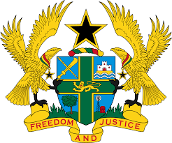
REPORT OF THE WORKING GROUP ON THE UNIVERSAL
PERIODIC REVIEW OF SENEGAL

STATEMENT BY GHANA DELIVERED BY MR. JOSEPH OWUSU-ANSAH,
COUNSELLOR, MONDAY 5TH NOVEMBER, 2018

Thank you, Mr. Vice President.

Ghana extends a warm welcome to the Honourable Minister of Justice of Senegal and his delegation to the 3rd UPR Cycle, and thanks them for their comprehensive national report and oral update.

My delegation commends the steps taken by Senegal since the 2nd UPR Cycle to promote and protect human rights and fundamental freedoms in the country. We welcome, in particular, the independence of the Senegalese Human Rights Committee, the resumption of the drafting process of the Children’s Code to combat child trafficking, and the adoption of the second national strategy for gender equality and equity for the period 2016–2026. My delegation encourages Senegal to continue with the implementation of these positive interventions.

To further strengthen human rights in Senegal, Ghana makes the following two recommendations:

- Continue to engage civil society organisations in the implementation of UPR recommendations;

- Continue with the ongoing campaign to combat gender-based violence in schools to improve girl child enrollment and their retention.

Ghana wishes Senegal every success with the review process.

I thank you.

