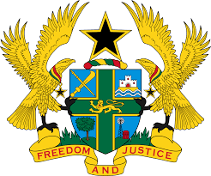
REPORT OF THE WORKING GROUP ON THE UNIVERSAL
PERIODIC REVIEW OF CENTRAL AFRICAN REPUBLIC

STATEMENT BY GHANA DELIVERED BY MR. ALEXANDER GRANT NTRAKWA,
DEPUTY PERMANENT REPRESENTATIVE, FRIDAY 9TH NOVEMBER, 2018

Thank you, Mr. Vice President.

Ghana extends a warm welcome to the delegation of Central African Republic to the UPR process.

My delegation commends Central African Republic for implementing numerous public policy interventions since the last UPR to advance the promotion and protection of human rights in the country. We welcome in particular the adoption of the Poverty Reduction Strategy Paper II (2011-2015), the National Education Sector Strategy 2008–2020, and the National Social Protection Policy among others.

We commend Central African Republic for remaining committed to upholding human rights and fundamental freedoms amidst events that threatened the country’s stability in 2013, and encourage the Government to continue with their efforts to entrench human rights values in all spheres of CAR society.

Given that the National Policy for the Protection of Children, and the National Strategic Plan for Housing have reached the validation stage, my delegation recommends Central African Republic ensure their quick adoption and implementation.

Ghana wishes Central African Republic a successful review.

I thank you.

