ቀዋሚ ሚሽን ሃገረ ኤርትራ ናብ ውድብ ሕቡራት ሃገራት  ጀኔቫ | 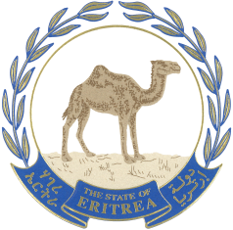  البعثة الدائمة لدولة إريتريا  لدى الأمم المتحدة | جنيف
Permanent Mission of the State of Eritrea to the United Nations
GENEVA

Thank you Mr. President
Eritrea welcomes the delegation of Kingdom of Saudi Arabia lead by H.E. Dr. Bander and congratulates him and his delegation for the report and presentation.
We noted with satisfaction the inward looking 2030 Saudi Vision adopted by the council of Ministers on the employment of the potential and God given resources to build a vibrant society, strong economy and ambitious nation.
My delegation believes that the commitment to look into one’s own resources is a recipe to development and self-reliance. We are also encouraged by the symbolic steps taken to guaranteeing gender equality.
On that note, I would like to recommend the Kingdom to fast track practical steps towards the implementation of programs on gender parity and improve the livelihood of people with disabilities and those vulnerable inherent in any society.
In conclusion, I would like to wish the delegation a successful review.
I thank you

