ቀዋሚ ሚሽን ሃገረ ኤርትራ ናብ ውድብ ሕቡራት ሃገራት  ጀኔቫ | 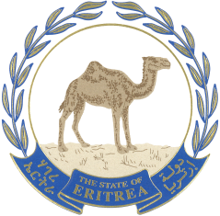  البعثة الدائمة لدولة إريتريا  لدى الأمم المتحدة | جنيف
Permanent Mission of the State of Eritrea to the United Nations
GENEVA

Thank you Mr. President,
I would like to congratulate the delegation of China for the presentation. My delegation believes that the UPR mechanism has been able to enjoy the support of all member states because it puts all countries in the same level playing field and is a state driven voluntary process that showed concrete results. I do not want to pass this opportunity without stating that China has been strong advocate of this viable mechanism and had in the past accepted most of the recommendations of the working group. I hope it will do the same this time. With this believe, my delegation would like to recommend China to:
- continue strengthen and develop legislation that promote and protect Labour and social rights; and
- strengthen the technical professional education system as quality education alternative for the development of the country.
I wish all the success for the delegation with the hope that our recommendations will be taken on board.
I thank you

