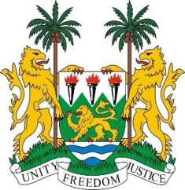
SIERRA LEONE
31st Session of the UPR

CONGO

14 November 2018

Mr President,

Sierra Leone welcomes the distinguished delegation from the Congo to this 31st session and thanks them for their presentation.

Since their last review, my delegation notes that the Congo abolished the death penalty in 201 5 and in 2018, the government approved a national action plan to implement Security Council resolution 1325 on women, peace and security.

My delegation commends the Congo on the ceasefire established earlier this year and hopes the government will consider establishing a commission to further strengthen peace and reconciliation efforts in the country.

Sierra Leone would however like to encourage the Congo to also consider reforming its Code of Criminal Procedure in order to raise the minimum age of criminal responsibility, and to develop and implement effective measures eliminating all forms of violence against children.

Recommendations:

- Ratify the ICPPED.
- Expedite their ratification of the 1954 Convention relating to the Status of Stateless Persons, and the 1961 Convention on the Reduction of Statelessness.
- Strengthen measures to further protect children with albinism and eliminate all forms of discrimination they face.

In conclusion, Sierra Leone wishes the Congo every success in completing this third review cycle.

Thank you, Mr President.

