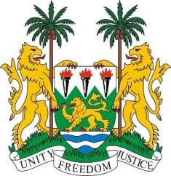
SIERRA LEONE
31st Session of the UPR

CHAD

13 November 2018

Mr President,

Sierra Leone welcomes the distinguished delegation from Chad to this 31st session and thanks them for their presentation.

Since its last review, my delegation notes that in 2015, legislation and measures were put into force to end child, early and forced marriage and more recently, Chad established a new National Human Rights Commission which is in conformity with the Paris Principles.

Sierra Leone commends Chad on the ratification of the AU’s Protocol to the African Charter on Human and Peoples’ Rights, and for implementing the 2017 – 2021 National Development Plan to among others, combat poverty and promote the right to education.

My delegation commends Chad on ratifying into national law, the CRPD in June 2018, and for their ongoing efforts to promote and protect the rights of persons with disabilities.

It is equally noteworthy that since 2012, Chad has a standing invitation for all special procedures mandate holders.

Recommendations:

- Develop comprehensive policies to combat sexual and gender-based violence against women and girls.
- Expedite the measures for the ratification of the ICPPED and the ICRMW.
- Continue to work with international stakeholders to fight terrorism and to promote good governance.

In conclusion, Sierra Leone wishes Chad success in implementing the accepted recommendations during this third review cycle.

Thank you, Mr President.

