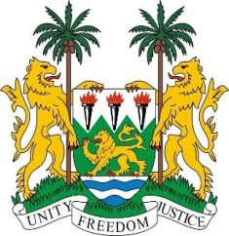
SIERRA LEONE
31st Session of the UPR

CENTRAL AFRICAN REPUBLIC

9 November 2018

Mr President,

Sierra Leone welcomes the distinguished delegation of the Central African Republic and thanks them for their presentation.

My delegation commends the CAR on the adoption of a new constitution in 2016 and the related constitutional reform, as well as the legislative efforts undertaken in 2018 to address gender-based violence and forced marriage.

Sierra Leone notes the various initiatives to promote stability through peace and reconciliation processes, and in 2017, the establishment of a national commission on human rights and fundamental freedoms in conformity with the Paris Principles.

Recommendations:
- Ratify the ICRMW.
- Strengthen policies and measures aimed at protecting children with disabilities, and children with albinism from attacks and prosecute perpetrators.
- Thoroughly investigate and prosecute all cases of sexual violence committed against women and girls.
- To put an immediate end to the current sectarian violence in the country.

Sierra Leone urges the international community to continue to support, through enhanced technical and financial assistance, the efforts of the CAR to meet its human rights commitments and obligations.

In conclusion, Sierra Leone wishes the Central African Republic every success in the implementation of the accepted recommendations during this third cycle.

Thank you, Mr President.

