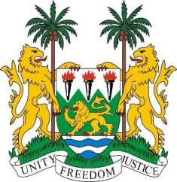
SIERRA LEONE
31st Session of the UPR

SENEGAL

5 November 2018

Mr President,

Sierra Leone welcomes the distinguished delegation of Senegal and thanks them for their presentation.

My delegation commends Senegal on establishing various child protection and educational strategies, including universal healthcare for all school children. More recently, they also established the first national action plan for the eradication of gender-based violence (2017 -2021), and implemented comprehensive policies to end child, early and forced marriage.

Recommendations:

- Intensify efforts to regain the “A” status of the Senegalese Human Rights Committee by bringing it in line with the Paris Principles.
- Raise the minimum age of marriage of both boys and girls to 18.
- Continue to strengthen efforts aimed at maintaining peace in the Casamance region.

Sierra Leone wishes Senegal every success in completing its third review cycle.

Thank you, Mr President.

