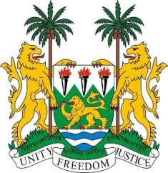
SIERRA LEONE
31st Session of the UPR

CHINA

6 November 2018

Mr President,

Sierra Leone warmly welcomes the distinguished Chinese delegation and thanks them for their presentation.

Sierra Leone notes with appreciation the huge financial and technical assistance provided to Sierra Leone and several African nations during the outbreak of the Ebola epidemic (of 2014 – 2016).

Recommendations:

- Ratify the ICCPR, and accede to the ICRMW and the ICPPED.
- Establish an independent human rights institution which is in conformity with the Paris Principles.
- Continue to strengthen public health education strategies and support NGO efforts in promoting community health services and social development.

Sierra Leone wishes China success in this third review cycle.

Thank you, Mr President.

