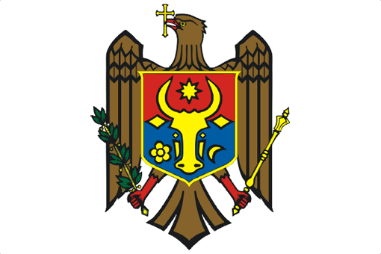

REPUBLIC OF MOLDOVA

UPR Working Group
31st Session

Examination of the Report of Malaysia

Statement of the Delegation of the Republic of Moldova

1 min 5 sec

Mr. President,

The Republic of Moldova welcomes the distinguished delegation of Malaysia to the UPR Working Group and thanks the delegation for the presentation of the national report.

The Republic of Moldova expresses appreciation to Malaysia for its engagement with the UPR and welcomes the commitment of the Government to the protection and promotion of human rights.

We particularly commend the decision to abolish the death penalty and thus recommend Malaysia to ensure the adoption of the necessary legislation in a timely manner.

Furthermore, we recommend Malaysia to ratify the remaining international human rights treaties and to ensure their implementation.

Third, we welcome the cooperation with human rights special procedures and consequently, recommend Malaysia to consider issuing a standing invitation to all Special Procedures of the Human rights Council.

We wish Malaysia a successful UPR.

Thank you, Mr. President.

