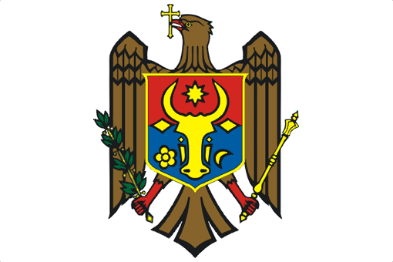

REPUBLIC OF MOLDOVA

UPR Working Group
31st Session
6 November 2018

Examination of the Report of Nigeria
Statement of the Delegation of the Republic of Moldova

The delegation of the Republic of Moldova welcomes the delegation of Nigeria to the UPR Working Group and thanks it for the presentation of the National Report.
The Republic of Moldova commends Nigeria for adopting, after the second cycle UPR, a series of essential laws for the protection and promotion of human rights, mainly the Anti-Torture Act (2017), the Trafficking in Persons Law Enforcement and Administration Act (2015), the Administration of Criminal Justice Act (2015) and the Violence against Persons Act (2015).
We particularly welcome the adoption of the “Not Too Young to Run” Act designed to promote youth participation in public and political life by reducing the age limit for running for elective office.
In order to reinforce the steps taken by Nigeria to advance the protection and promotion of human rights and fundamental freedoms, we would like to make the following recommendations:
- Adopt the Gender and Equal Opportunities Bill and ensure its effective implementation at all levels of government.
- Implement a moratorium on the death penalty and take steps to ratify the Second Optional Protocol to the International Covenant on Civil and Political Rights, aiming at the abolition of the death penalty.
- Take further positive measures to promote youth participation in public and political life.
I thank you, Mr. President.

