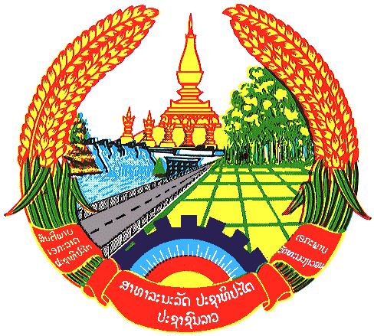

Statement by the delegation of the Lao PDR
At the 31th Session of UPR Working Group
Geneva, 5-16 November 2018

Review of Jordan: 8 November 2018, at 09:00 - 12:30 hours

Mr. President,
The Lao delegation would like to welcome the delegation of Jordan and congratulate for its UPR report presented to the council.

We welcome the progress of Jordan’s efforts in promoting and protecting human rights in the country, including the adoption of national policies, strategies and plans, which are in line with human rights principles and international standards.

Taking this opportunity, we would like to recommend Jordan to:

- Continue its efforts to promote the rights of women through education and training programme; and
- Continue to upgrade the living standards and conditions of persons with disabilities, especially children with disabilities to ensure that their basic needs are met.

We wish Jordan all the best in its UPR.

I thank you, Mr. President.

