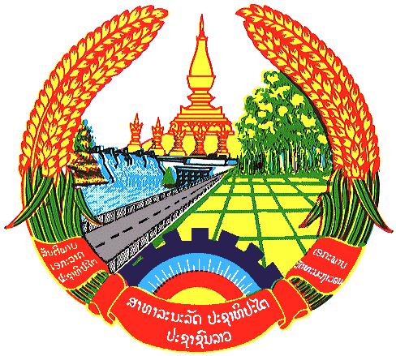

Statement by Mr. Sitsangkhom SISAKETH
Counsellor and Deputy Permanent Representative
Permanent Mission of the Lao PDR
At the 31th Session of UPR Working Group
Geneva, 5-16 November 2018

Review of Malta: 14 November 2018, at 14:30 - 18:00 hours

Mr. President,
The Lao delegation warmly welcome the delegation of Malta and congratulates its comprehensive report, demonstrating human rights development in the country.

The Lao PDR commends Malta on making good progress in implementing the recommendations made in the previous UPR, including the rights of the children, women and persons with disabilities through its various legislative initiatives and measures.

In this respect, we wish to recommend Malta as follows:

- Continue its effort to strengthen policies and strategies, aimed at promoting and protecting the rights of children and women; and
- Continue its commitment to promoting the empowerment of persons with disabilities to ensure equal opportunities are represented to them.

We wish Malta all the best in its UPR.

I thank you, Mr. President.

