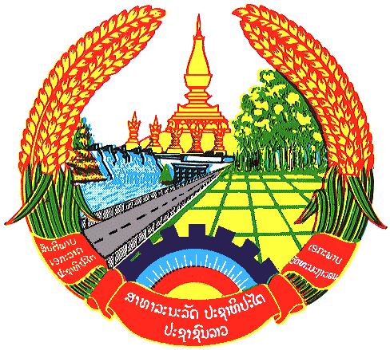

Statement by Mr. Sitsangkhom SISAKETH
Counsellor and Deputy Permanent Representative
Permanent Mission of the Lao PDR
At the 31th Session of UPR Working Group
Geneva, 5-16 November 2018

Review of Republic of the Congo: 14 November 2018, at 09:00 - 12:30 hours

Mr. President,
The Lao delegation welcomes the delegation of the Republic of the Congo and also welcomes its comprehensive report, which signifies the development of human rights in the country.

We commend the Republic of the Congo for the progress made in the implementation of the recommendations accepted during its 2nd UPR, including the promotion and protection of children’s rights and rights of persons with disabilities.

In this respect, we wish to recommend the Republic of the Congo the following:

- Continue to strengthen its national policies to further promote and protect children’s rights and rights of persons with disabilities; and
- Continue to promote economic, social and cultural rights through the implementation of its National Development Plan.

We wish the Republic of the Congo every success in its review.

I thank you, Mr. President.

