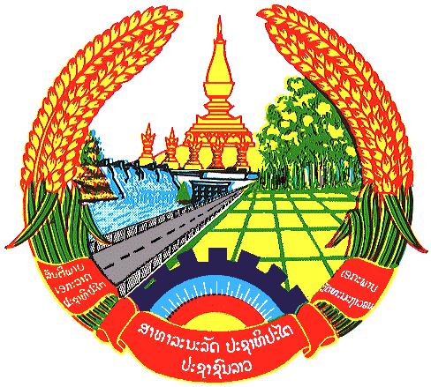

Statement by the delegation of the Lao PDR
At the 31th Session of UPR Working Group
Geneva, 5-16 November 2018

Review of Central African Republic: 9 November 2018, at 09:00 - 12:30 hours

Mr. President,
The Lao delegation welcomes the Delegation of the Central African Republic to the UPR Session and congratulate its comprehensive report on the development of human rights.

The Lao PDR commends the Government of Central African Republic for its continued efforts in implementing the adopted numerous legislations and policies at the national level in the field of promotion and protection of human rights. We also positively note that the protection of women has been a priority for the Government of Central African Republic.

In this respect, we wish to recommend as follows:

- Continue to promote reconciliation and co-existence among the various communities as well as human rights education and culture of peace throughout the country; and
- Continue to promote the rule of law in order to ensure effective implementation of human rights.

We wish Central African Republic all the success in its UPR.

I thank you, Mr. President.

