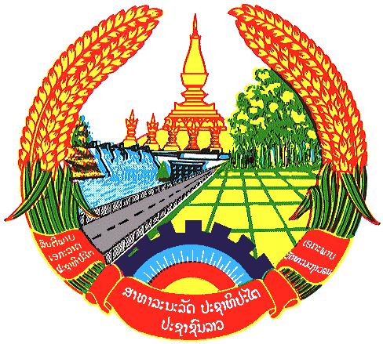

Statement by the delegation of the Lao PDR
At the 31th Session of UPR Working Group
Geneva, 5-16 November 2018

Review of Mexico: 7 November 2018, at 09:00 - 12:30 hours

Mr. President,
The Lao delegation welcomes the delegation of the Mexico to the UPR session and would like to thank for its update of the National Report on human rights.

We commend the Government of Mexico for taking initiatives in implementing the recommendations made in the previous UPR and as well as the conclusion of the National Development Plan and the National Human Rights Programme, which include guidelines for addressing recommendations of the second cycle on the UPR.

We wish to make the following recommendations:

- Continue its efforts to implement the National Development Plan in order to encourage sustainable social development as a condition for the progress realization of human rights; and
- Continue to provide scholarship programme for children, adolescents and young persons, including in the rural and remote area to ensure that children are in the educational system.

We wish Mexico every success in its UPR.

I thank you, Mr. President.

