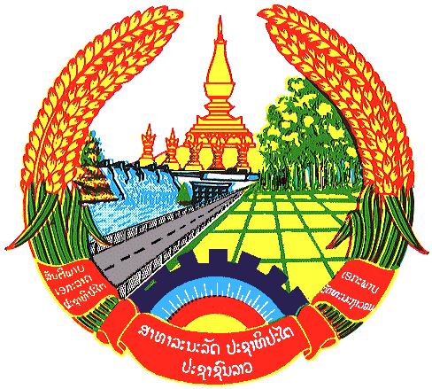

Statement by the delegation of the Lao PDR
At the 31th Session of UPR Working Group
Geneva, 5-16 November 2018

Review of Senegal: 5 November 2018, at 09:00 - 12:30 hours

Mr. President,
The Lao PDR welcomes the Delegation of the Senegal to the 31th Session of the UPR and would like to thank the head of delegation for the comprehensive presentation of the National Report.

We commend the Government of Senegal for the progress made of its commitment in implementing human rights at the national level through a constructive cooperation with the international human rights mechanisms. This includes the promotion of Children’s rights, Women’s rights, Rights to education, Rights to health and poverty alleviation.

In this connection, we wish to make three following recommendations:

- Continue to intensify its efforts to address the challenges, constraints and obstacles a presented in the report, in the promotion and protection of human rights;
- Continue to strengthen the national human rights bodies, especially for the advancement of women and children; and
- Continue to pursue a policy to upgrade the quality of teaching and learning at all level.

We wish Senegal all the success in its Third Cycle of UPR.

I thank you, Mr. President.

