Permanent Mission of Rwanda
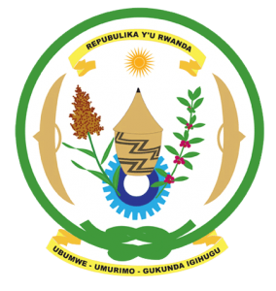
31st Session of the Universal Periodic Review Working Group

Review of The Republic of Congo

14th November 2018

Statement delivered by H.E. Dr. Francois Xavier Ngarambe

Ambassador and Permanent Representative
Thank you, Mr. President,
- Rwanda warmly welcomes the delegation of the Republic of Congo and thanks them for the presentation of their national report and the update just provided.
- Rwanda commends the Congo for its continued efforts to promote and protect human rights including through the adoption of legislation and implementation of various policies to improve the situation of human rights. We further commend the Congo for its exemplary cooperation with international and regional human rights mechanisms.
- Rwanda encourages the Congo to strengthen measures to combat domestic violence and violence against women including through the implementation of relevant legislation to ensure justice for victims.

Rwanda recommends that the Republic of Congo:
- Take concrete measures towards the ratification of the Second Optional Protocol to the International Covenant on Civil and Political Rights. We thank the Minister of Justice for his update in this regard.
- Consider ratifying the Convention on the Prevention and Punishment of the Crime of Genocide
- Continue its implementation of the Cessation Clause for Rwandan Refugees.

Rwanda wishes the Republic of Congo a successful review outcome. Thank you

