Permanent Mission of Rwanda
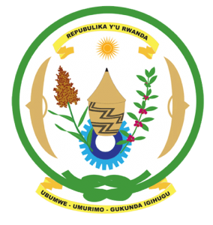
31st Session of the Universal Periodic Review Working Group

Review of Chad

13th November 2018

Statement delivered by Mr. Moses Rugema
Thank you, Mr. Vice President,
- Rwanda warmly welcomes the delegation of Chad and thanks them for the presentation of their national report and the update just provided.
- Rwanda commends Chad for its continued efforts to promote and protect human rights in a challenging security and socio-economic context.
- Rwanda welcomes Chad’s efforts to bring its National Human Rights Commission in line with the Paris Principles and encourages them to enhance those efforts to ensure it is fully in line with the Paris Principles.
- Rwanda further welcomes the adoption of legislation on gender parity in elections and appointments and calls on the government of Chad to ensure its implementation.

Rwanda recommends that Chad:
- Take concrete measures to introduce a de jure moratorium on the use of the death penalty with a view towards its total abolition.
- Consider ratifying the Convention on the Prevention and Punishment of the Crime of Genocide
- Strengthen implementation of legislation and policies aimed at ending harmful traditional practices in particular child, early and forced marriages and female genital mutilation.

Rwanda wishes Chad a successful review outcome. Thank you

