***Permanent Mission of Rwanda***

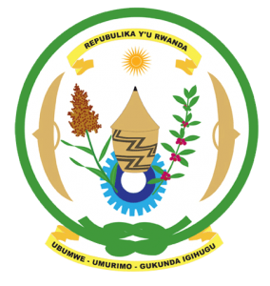

**31st Session of the Universal Periodic Review Working Group**

**Review of Central African Republic**

**9th November 2018**

**Statement delivered by Mr. Moses Rugema**

Thank you, Mr. Vice President,

1. Rwanda warmly welcomes the delegation of the Central African Republic and thanks them for the presentation of their national report and the update just provided.
2. Rwanda commends the Central African Republic for its continued efforts to promote and protect human rights in a complex political, security and socio-economic context. Rwanda particularly welcomes the Central African Republic’s ratification of the Convention on the Prevention and Punishment of the Crime of Genocide, the establishment and operation of the Special Criminal Court and the adoption and implementation of the act establishing parity between men and women in public, semi-public and private-sector employment.

**Rwanda recommends that the Central African Republic:**

* Expedite efforts aimed at the de facto abolition of the death penalty including the process of revision of the provisions of the Criminal Code.
* Strengthen efforts to combat violence against women and ensure the investigation, prosecution and punishment of all cases of violence against women and the full operationalization of the Joint Unit for Rapid Intervention and Suppression of Sexual Violence against Women and Children (UMIRR).
* Take active measures to prevent the recruitment and use of children by armed groups.

Rwanda wishes the Central African Republic a successful review. Rwanda remains ready to continue supporting the Central African Republic in the process of consolidating peace and security and the promotion and protection of human rights.