Permanent Mission of Rwanda
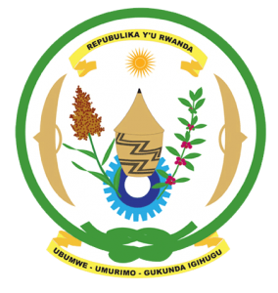
31st Session of the Universal Periodic Review Working Group

Review of Mauritius

7th November 2018

Statement delivered by H.E. Dr. Francois Xavier Ngarambe

Ambassador and Permanent Representative
Thank you, Mr. Vice President,
- Rwanda welcomes the delegation of Mauritius and thanks them for the presentation of their national report and the update just provided.
- Rwanda welcomes the many positive steps taken by Mauritius to promote human rights and strengthen the institutional framework for the promotion and protection of human rights. In that regard, we welcome the positive steps taken by Mauritius, including the amendment to its National Women’s Council Act to further promote women’s empowerment and gender equality and its strengthened cooperation with the Treaty Bodies.
- While noting progress made in promoting gender equality, Rwanda recommends that Mauritius enhance those efforts particularly with regard to the under-representation of women in political and decision-making positions.

Rwanda recommends that Mauritius:
- Considers issuing a standing invitation to the UN human rights Special Procedures, while noting Mauritius’s exemplary cooperation with the United Nations Human Rights Mechanisms.
- Consider ratifying the Convention on the Prevention and Punishment of the Crime of Genocide. We welcome the update given by the head of delegation in that regard.
We wish Mauritius every success in the implementation of the recommendations of this UPR. Thank you

