Permanent Mission of Rwanda
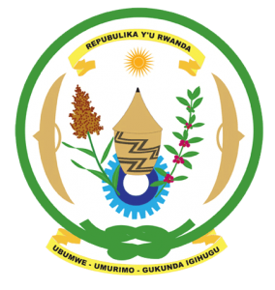
31st Session of the Universal Periodic Review Working Group

Review of Mexico

7th November 2018

Statement delivered by Mr. Moses Rugema

Thank you, Mr. President,
- Rwanda welcomes the delegation of Mexico and thanks them for the presentation of their national report and the update just provided.
- Rwanda welcomes the positive steps that have been taken by Mexico to implement the recommendations of its last UPR including through the adoption of legislation and implementation of policies aimed at the promotion and protection of human rights and the full realisation of human rights.
- While welcoming efforts to combat human trafficking, Rwanda recommends that Mexico adopt more proactive measures to comprehensively address human trafficking and ensure accountability for victims, particularly women and girls who are disproportionately affected.

Rwanda recommends that Mexico:
- Take all appropriate measures to address patriarchal attitudes and gender stereotypes including reviewing laws, customs and practices that may constitute discrimination against women and girls.
- Adopt concrete measures to address marginalisation and discrimination against persons of African descent, including through enhancing institutional capacity to systematically document, investigate and prosecute acts of discrimination.

We wish Mexico a successful review. Thank you

