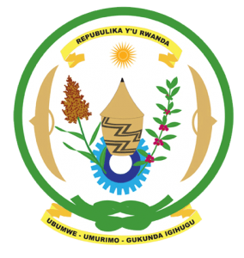
31st Session of the Universal Periodic Review Working Group
Review of Nigeria
6th November 2018

Statement by Rwanda delivered by Moses Rugema
Thank you, Mr. Vice-President,
- Rwanda warmly welcomes the delegation of Nigeria and thanks them for the presentation of their national report and the update just provided.
- Rwanda welcomes the many positive steps taken by the government of Nigeria to promote and protect human rights including through implementation of the recommendations of its second cycle UPR.
- While welcoming efforts to promote women’s rights and to eliminate all forms of discrimination against women, we encourage Nigeria to enhance measures to ensure gender equality in political participation.

Rwanda recommends that Nigeria:
- Take concrete measures to introduce a de jure moratorium on the death with a view towards its total abolition.
- Strengthen implementation of legislation and policies aimed at ending harmful traditional practices in particular through adoption of the enforcement procedure of Nigeria’s Violence against Persons (Prohibition) Act.

We wish Nigeria every success in their review. Thank you.

