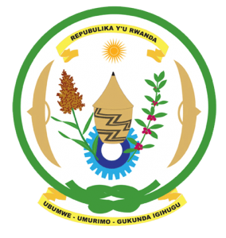
31st Session of the Universal Periodic Review Working Group
Review of China
6th November 2018

Statement by Rwanda delivered by H.E. Dr. Francois Xavier Ngarambe

Ambassador and Permanent Representative

- Rwanda warmly welcomes the delegation of China and thanks them for the presentation of their national report and the update just provided.
- Rwanda commends China’s continued efforts to promote and protect human rights including through implementation of policies to improve the social and economic wellbeing of its citizens.
Rwanda recommends that China:
- Strengthen measures to combat violence against women and domestic violence including through enhancing existing legislation to better ensure accountability for victims.
- Consider further limitations on the use of the death penalty with a view to imposing a de facto moratorium on its use and aiming at its total abolition.

We wish China every success in the implementation of the accepted recommendations of this review.
Thank you.

