Permanent Mission of Rwanda
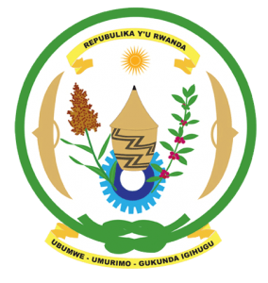
31st Session of the Universal Periodic Review Working Group

Review of Senegal

5th November 2018

Statement delivered by Mrs. Eliane Nzabahimana

Thank you, Mr. Vice President,
- Rwanda warmly welcomes the delegation of Senegal led by the Honourable Minister of Justice Ismaila Fall, and thanks them for the presentation of their national report and the update just provided.
- Rwanda commends Senegal for its considerable efforts to promote and protect human rights and for the progress it has registered in improving the social and economic status of its citizens through the adoption of several legislative measures and implementation of policies to address specific human rights challenges.
- While noting progress made in combating discrimination against women, we encourage Senegal to enhance those efforts through implementing relevant laws and to consider adopting a comprehensive sexual and reproductive health policy for adolescents.

Rwanda recommends that Senegal:
- Strengthens its legal framework for the promotion and protection of women’s rights and gender equality including through ensuring its legislation is in line with the definition of discrimination in article 1 of the CEDAW.
- Ratifies the Second Optional Protocol to the International Covenant on Civil and Political Rights, aiming at the abolition of the death penalty.
We wish Senegal every success in the implementation of the recommendations of this UPR. Thank you

