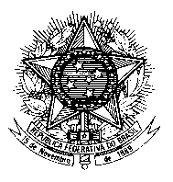
Permanent Mission of Brazil to the United Nations in Geneva

Human Rights Council
Universal Periodic Review – 29th Session
Review of Malta
14 November 2018

Mr. President,

Brazil welcomes the delegation of Malta to the third cycle of the UPR and thanks it for the presentation of its report.

We praise the achievements of the country regarding social inclusion, reduction of poverty and access to education, with emphasis in children, youth, older people, poorer workers and unemployed persons.

We also commend Malta for adopting specific legislation against violence and discrimination based on sexual orientation and gender identity, including the recent legalization of same-sex marriage and the approval of the gender identity, gender expression and sex characteristics act, which regulates the rights of transgender people to their gender identity.

In light of such positive achievements and with a view to further enhancing the human rights situation, Brazil recommends that Malta:

1. Ensure that migrants and refugees rescued at sea are promptly disembarked in full respect to human rights, without arbitrary detention, and are given a genuine opportunity to seek asylum, and refrain from criminalizing persons involved in rescue activities at sea.

2. Guarantee that an independent and effective public inquiry into the killing of journalist Daphne Caruana Galizia is carried out and enhance policies aimed at ensuring the safety of journalists.

Thank you.
(195 words)

