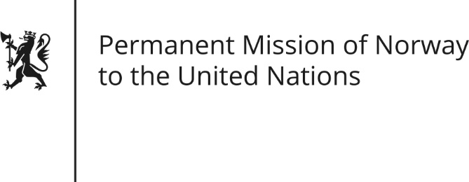

STATEMENT by First Secretary Sean Lobo

31th Session of the Universal Periodic Review

Central African Republic

9 November 2018

Check against delivery
President,
Norway welcomes the Central African Republic’s participation in the UPR[, creation of the National Commission on Human Rights and Fundamental Freedoms and commitment to revise the Criminal Code with the aim to abolish death penalty.]
[The security situation has detrimental effects on the human rights situation. We are particularly concerned about the increase of sexual and gender based violence.]
Norway recommends:
- Adopt more effective measures to end impunity related to sexual and gender-based violence, including by rehabilitating the judicial infrastructure outside the capital.
- Ensure a vetting mechanism of all security forces regarding possible human rights abuses and provide thorough training on compliance and promotion of human rights.
- Ensure protection and assistance for displaced persons, in accordance with the Guiding Principles on Internal Displacement.
- Strengthen the efforts to ensure the right to education and health services.
Thank you.

