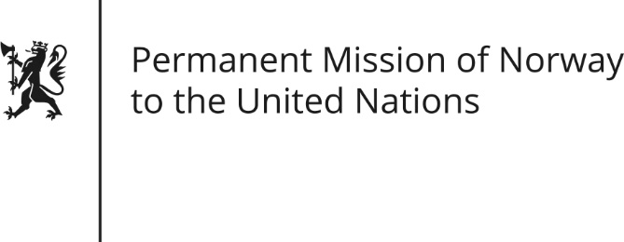

STATEMENT by Minister Counsellor Herborg F. Alvsaaker

31th Session of the Universal Periodic Review

Malaysia

8 November 2018

Check against delivery
President,

Norway welcomes Malaysia’s participation in the UPR and notes the positive statements already made by the new government on its intentions to improve the human rights situation in the country. We applaud your ambition and look forward to the implementation of the reforms.
(Kortere versjon: Norway welcomes the positive statements made by Malaysia’s new government on its intentions to improve the human rights situation in the country. We applaud and support your ambition.)

Norway recommends that Malaysia
1) Abolishes the death penalty.
2) Withdraws all reservations to CEDAW and abandon discriminatory laws against all women regardless of their ethnic or religious background.
3) Ratifies and implements all remaining core human rights treaties.
4) Ensures the rights of indigenous peoples in law and practice, in particular regarding their right to traditional lands, territories and resources.
Thank you.

