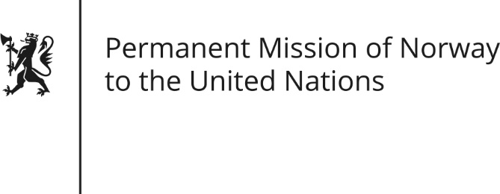

STATEMENT by First Secretary Sean Lobo

31th Session of the Universal Periodic Review

Jordan

8 November 2018

Check against delivery
President,

Norway commends Jordan for its progress since the last UPR hearing, in particular the repeal of Article 308 in the Penal Code.

[Norway remains concerned about the rights of women in Jordan, freedom of speech and access to basic legal guarantees.]

Norway recommends:

1) to withdraw all reservations to CEDAW and amends the legislation to bring it into compliance with the convention[, including by amending provisions of the Personal Status Act and Nationality Act].
2) ensure that all domestic legislation is in compliance with the ICCPR, in particular in relation to the right to freedom of expression.
3) end the use of administrative detention and introduce legislation to guarantee access to a lawyer from the point of arrest.
4) that Jordan abolish the death penalty.
[5) to ratify without any reservation, the Agreement on the Privileges and Immunities of the International Criminal Court.]
Thank you.

