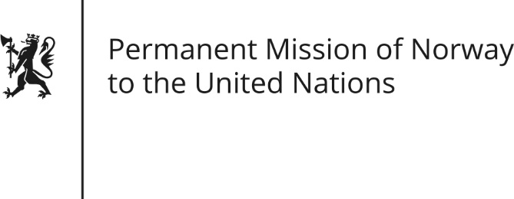

STATEMENT by Adviser Line Hammeren

31th Session of the Universal Periodic Review

Mexico

7 November 2018

Check against delivery
President,
Norway welcomes Mexico’s multilateral engagement in the field of human rights. We remain, however, deeply concerned about the domestic situation in the country with alarmingly high levels of impunity and violence.
Norway recommends:
1) That Mexico takes further steps to tackle impunity by guaranteeing the independence and impartiality of the judiciary, thereby ensuring that judges are free from any interference, pressure or undue influence in the exercise of their functions.
2) That Mexico takes concrete steps to combat arbitrary detentions and torture of detainees, including by establishing a nationwide and consistent register of arrests(, in line with international human rights law).
3) That Mexico intensifies their efforts to reduce the high levels of gender-based violence against women (including by evaluating and modifying, the procedure for activating the Gender Violence Alert mechanism in broad consultation with civil society.)
Thank you.

