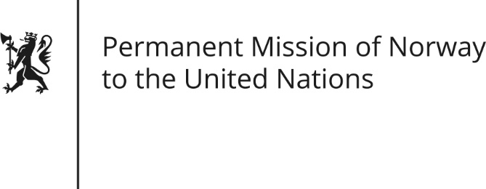

STATEMENT by First Secretary Sean Lobo

31th Session of the Universal Periodic Review

Nigeria

6 November 2018

Check against delivery
President,
(Norway welcomes Nigeria’s participation in the UPR).
Norway remains concerned about the rights of women and children. (Women must be included in decision-making at all levels.)
Norway recommends:
1) Protect and promote the rights of women and girls, including by enhancing reproductive health, ending harmful traditional practices and take concrete measures against sexual and gender-based violence.
2) Further develop strategies, and ascertain the implementation of such, to ensure that all citizens (regardless of status, gender or location) have equal access to quality healthcare and education.
3) Create and maintain a safe and enabling environment for human rights defenders including those working on environmental issues.
4) Consider inviting the Special Rapporteurs on Human Rights Defenders and Human Rights and Environment, including to the Niger Delta.
Thank you.

