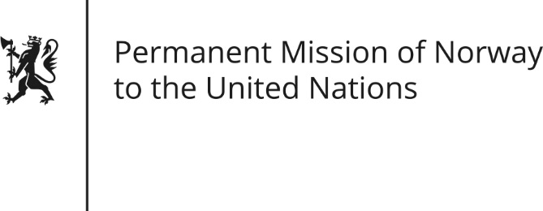

STATEMENT by DPR Chargée Trine Heimerback

31th Session of the Universal Periodic Review

People’s Republic of China

6 November 2018

Check against delivery
President,
Norway welcomes China’s active participation in the UPR and notes the positive steps taken since its last review, including poverty reduction and progress in the implementation of Agenda 2030.
Norway remains concerned about certain human rights issues in China. Measures to counter terrorism and prevent radicalisation and violent extremism must be human rights compliant.
Norway recommends:
1) Full transparency on the situation for religious minorities in Xinjiang, including by allowing UN-mandated observers unrestricted access to places of internment in the region.
2) To create and maintain a safe and enabling environment for all human rights defenders.
3) To take steps towards abolishing the death penalty.
4) To respect, protect and ensure the freedom of expression of all citizens.
Thank you.

