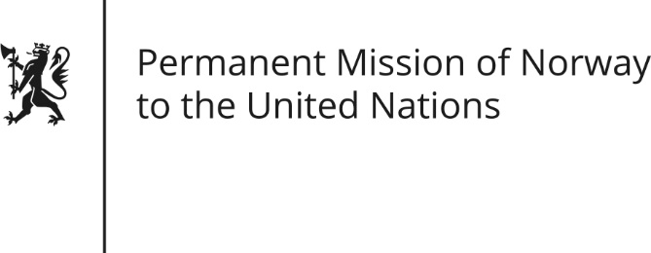

STATEMENT by DPR Chargée Trine Heimerback

31th Session of the Universal Periodic Review

Kingdom of Saudi Arabia

5 November 2018

Check against delivery
President,
Norway welcomes Saudi Arabia’s participation in the UPR and positive steps taken (to include women in society, especially at workplaces, as recognized).
However, Norway remains gravely concerned about the deteriorated situation for human rights defenders, including journalists, and the rights to freedom of expression and peaceful assembly.
Norway recommends:
1) To ensure a safe and enabling environment for all human rights defenders, in particular for women human rights defenders and journalists.
2) Ensure that the country’s counter-terrorism legislation complies with international human rights norms, (including revising the broad definition of terrorism and no longer make it applicable to non-violent expressions).
3) Adopt measures to eliminate all remaining forms of discrimination against women, (including abolishing the guardianship system).
4) Establish a moratorium on executions as a step to abolish death penalty.

Thank you.

