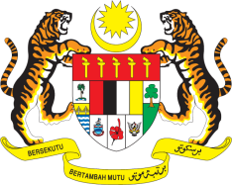

STATEMENT BY MALAYSIA
Review of Mauritius
31st Session of the UPR Working Group
7 November 2018

Mr. President,

The delegation of Malaysia wishes to extend a warm welcome to the esteemed delegation of Mauritius to its UPR review.

2. Malaysia applauds the progress made by Mauritius since its 2nd UPR and the philosophical approach of “achieving meaningful change” in promoting and protecting human rights. We also note the progress made by Mauritius in terms of poverty eradication, with extreme poverty down to less than 1%.

3. Malaysia lauds Mauritius’ efforts at providing access to health for infants and children, leading to the 33% decline in infant mortality rate since 1990. We also commend Mauritius for adopting a rights-based approach for implementing policies for persons with disabilities.

4. In this regard, Malaysia wishes to make the following recommendations:

  - Continue successful efforts at ensuring an adequate standard of living of Mauritians; and
  - Continue to sensitize both adults and children to the rights of children, particularly in the context of child poverty and child sexual abuse.

5. We wish Mauritius every success in its efforts in the promotion and protection of human rights.

Thank you, Mr. President.

GENEVA
7 November 2018

