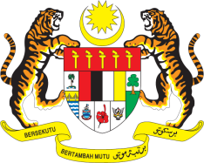

STATEMENT BY MALAYSIA
Review of Nigeria
31st Session of the UPR Working Group
6 November 2018

Mr. President,

Malaysia wishes to extend a warm welcome to His Excellency Abubakar Malami, the Attorney General and Minister of Justice of Nigeria, as well as members of his esteemed delegation.

2. Malaysia commends Nigeria for the development of a multi-stakeholder and inclusive approach National Policy Framework and Action Plan on Preventing Violent Extremism. We believe that this Framework and Action Plan will contribute to addressing the problem of radicalization through such mechanisms as education, awareness programmes, the training of religious leaders and re-integration policies.

3. Malaysia also welcomes Nigeria’s Economic Recovery and Growth Plan 2017-2020 (ERGP), with its vision of sustained inclusive growth and investment in human capital, as well as the health and education sectors, all of which are in line with the Sustainable Development Goals (SDGs).

4. In this regard, Malaysia wishes to recommend the following:

4.1. continue efforts to provide women access to economic opportunities, such as through the Business Development Fund for women (BUDFOW) and the National Women Empowerment Fund; and

4.2. continue to implement policies to ensure the availability of healthcare providers to those living in rural and other difficult to access areas.

5. We wish Nigeria every success in its goals in the promotion and protection of human rights.

Thank you, Mr. President.

GENEVA
6 November 2018

