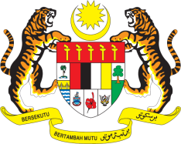

STATEMENT BY MALAYSIA
Review of Chad
31th Session of the UPR Working Group
6-17 November 2018

Mr. President,

The delegation of Malaysia wishes to extend a warm welcome to the esteemed delegation of Chad to its UPR review.

2. We are pleased to note that the Government of Chad has taken the necessary legislative action to ensure that the National Human Rights Commission is in compliance with the Paris Principles, as well as recognition in the Constitution of its NHRI as a major institution of the country. We also welcome the steps taken by Chad to improve prison conditions, protect consumer rights, as well as address the problem of cyber-crime.

3. Malaysia wishes to make the following recommendations:

3.1. To further reinforce efforts to promote maternal health as well as education for young girls; and

3.2. Continue its constructive collaboration and engagement with human rights bodies, mechanism and relevant mandate holders.

We wish Chad every success in its efforts in the promotion and protection of human rights.

Thank you, Mr. President.

GENEVA
7 November 2018

